ASSIGNMENT-5
Subject – Computer Science Workshop-1(CSE 2141)
NAME – DEEPTESH ROUT
Registration Number – 2341018166
Section – 23412G1 Branch – B. Tech (CSE)

1. Create an HTML page for the school management system with proper headings and an introduction paragraph. The page will also contain a login facility with a username, password and login button. Add CSS to assign proper styling to these fields. The password should be validated with at least 1 uppercase, 1 lowercase and 1 digit.

HTML CODE :-

<!DOCTYPE html>
<html lang="en">
<head>
<title>School Management System - Login</title>
<link href="https://cdn.jsdelivr.net/npm/bootstrap@5.3.0/dist/css/bootstrap.min.css" rel="stylesheet">
<script src="https://code.jquery.com/jquery-3.6.0.min.js"></script>
</head>
<body>
<header class="container mb-6">
<h1 class="text-center">ITER (School Management System)</h1>
<p class="text-center">Efficiently manage school operations and streamline communication of ITER</p>
</header>

<div class="container mt-5">
<div class="card mx-auto" style="max-width: 500px;">
<div class="card-body">
<h5 class="card-title text-center">Login</h5>

<form id="loginForm">
<div class="mb-3">
<label for="username" class="form-label">Username:</label>
<input type="text" class="form-control" id="username" name="username" required>
</div>

<div class="mb-3">
<label for="password" class="form-label">Password:</label>
<input type="password" class="form-control" id="password" name="password" required>
<div class="text-danger mt-1" id="passwordError" style="display: none;">Password must contain at least 1 uppercase, 1 lowercase, and 1 digit.</div>
</div>

<button type="button" class="btn btn-primary w-100" id="loginButton">Login</button>
</form>

<a id="redirectLink" href="QUESTION2.html" style="display: none;"></a>
</div>
</div>
</div>

<script>
$(document).ready(function () {
$('#loginButton').on('click', function () {
const password = $('#password').val();
const passwordError = $('#passwordError');
const passwordRegex = /^(?=.*[a-z])(?=.*[A-Z])(?=.*\d).+$/;

if (!passwordRegex.test(password)) {
passwordError.show();
} else {
passwordError.hide();
$('#redirectLink')[0].click();
}
});
});
</script>
</body>
</html>

OUTPUT OF THE CODE

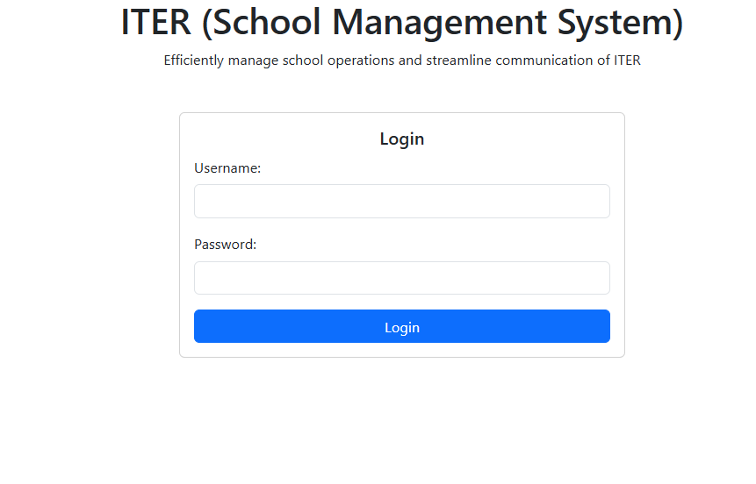

2. The login page is designed for Q1. The user will be moved to the Student Information page when clicking on the login button. Create a student table using HTML with Name, Age, Semester, and Registration Number. The alternative rows of the table should be of different colors. Add Edit and Delete buttons for each row and implement their functions. Style the Edit and Delete buttons with different colors.

HTML CODE:-
<!DOCTYPE html>
<html lang="en">
<head>
<meta charset="UTF-8">
<meta name="viewport" content="width=device-width, initial-scale=1.0">
<title>School Management System</title>
<link href="https://cdn.jsdelivr.net/npm/bootstrap@5.3.0/dist/css/bootstrap.min.css" rel="stylesheet">
<script src="https://code.jquery.com/jquery-3.6.0.min.js"></script>
<style>
.table-striped tbody tr:nth-of-type(odd) { background-color: #f9f9f9; }
.table-striped tbody tr:nth-of-type(even) { background-color: #e9ecef; }
.btn-edit { background-color: #ffc107; color: #fff; }
.btn-edit:hover { background-color: #e0a800; }
.btn-delete { background-color: #dc3545; color: #fff; }
.btn-delete:hover { background-color: #c82333; }
</style>
</head>
<body>
<div class="container mt-5">
<h2 class="text-center text-primary">Student Information</h2>
<table class="table table-striped">
<thead class="table-dark">
<tr>
<th>Name</th>
<th>Age</th>
<th>Semester</th>
<th>Registration Number</th>
<th>Actions</th>
</tr>
</thead>
<tbody>
<tr>
<td>Sanket Sidhivinayak</td>
<td>19</td>
<td>3</td>
<td>9465</td>
<td>
<button class="btn btn-edit btn-sm">Edit</button>
<button class="btn btn-delete btn-sm">Delete</button>
</td>
</tr>
<tr>
<td>Deeptesh Rout</td>
<td>20</td>
<td>3</td>
<td>8166</td>
<td>
<button class="btn btn-edit btn-sm">Edit</button>
<button class="btn btn-delete btn-sm">Delete</button>
</td>
</tr>
<tr>
<td>Aayush Kumar Singh</td>
<td>21</td>
<td>3</td>
<td>9469</td>
<td>
<button class="btn btn-edit btn-sm">Edit</button>
<button class="btn btn-delete btn-sm">Delete</button>
</td>
</tr>
<tr>
<td>Shrijan</td>
<td>19</td>
<td>3</td>
<td>9454</td>
<td>
<button class="btn btn-edit btn-sm">Edit</button>
<button class="btn btn-delete btn-sm">Delete</button>
</td>
</tr>
</tbody>
</table>
</div>

<script>
$(document).ready(function () {
// Delete action
$(document).on('click', '.btn-delete', function () {
if (confirm('Are you sure you want to delete this student?')) {
$(this).closest('tr').remove();
}
});

// Edit action
$(document).on('click', '.btn-edit', function () {
alert('You have selected to edit this student.');
});
});
</script>
</body>
</html>

OUTPUT OF THE CODE :-
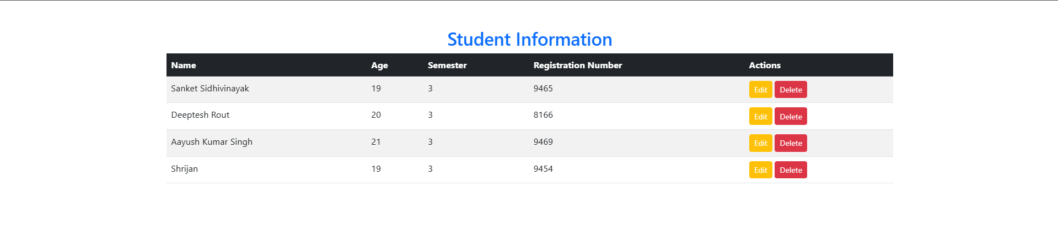

3. Consider the student table designed in Q2 and add a search bar that allows filtering of students by their names and displays only matching rows (use .filter() of jQuery). Also, highlight the table row on hover with a different background color to fade in and out.

HTML CODE

<!DOCTYPE html>
<html lang="en">

<head>
<meta charset="UTF-8">
<meta name="viewport" content="width=device-width, initial-scale=1.0">
<title>School Management System</title>
<link href="https://cdn.jsdelivr.net/npm/bootstrap@5.3.0/dist/css/bootstrap.min.css" rel="stylesheet">
<script src="https://code.jquery.com/jquery-3.6.0.min.js"></script>
<style>
.table-striped tbody tr:nth-of-type(odd) {
background-color: #f9f9f9;
}
.table-striped tbody tr:nth-of-type(even) {
background-color: #e9ecef; }
.btn-edit {
background-color: #ffc107;
color: #fff;
}
.btn-edit:hover {
background-color: #e0a800;
}
.btn-delete {
background-color: #dc3545; color: #fff;
}
.btn-delete:hover {
background-color: #c82333;
}
.search-bar {
padding: 10px;
width: 90%; margin-bottom: 10px;
border-radius: 20px;
}
tr:hover {
background-color: #e0e0e0;
cursor: pointer;
transition: background-color 0.3s ease;
}
</style>
</head>

<body>
<div class="container mt-5">
<h2 class="text-center text-primary">Student Information</h2>
<input type="text" id="search" class="search-bar" placeholder="Search by student name...">
<table class="table table-striped">
<thead class="table-dark">
<tr>
<th>Name</th>
<th>Age</th>
<th>Semester</th>
<th>Registration Number</th>
<th>Actions</th>
</tr>
</thead>
<tbody>
<tr>
<td>John Doe</td>
<td>20</td>
<td>4</td>
<td>123456</td>
<td>
<button class="btn btn-edit btn-sm">Edit</button>
<button class="btn btn-delete btn-sm">Delete</button>
</td>
</tr>
<tr>
<td>Jane Smith</td>
<td>21</td>
<td>6</td>
<td>654321</td>
<td>
<button class="btn btn-edit btn-sm">Edit</button>
<button class="btn btn-delete btn-sm">Delete</button>
</td>
</tr>
<tr>
<td>Emma Brown</td>
<td>22</td>
<td>8</td>
<td>789012</td>
<td>
<button class="btn btn-edit btn-sm">Edit</button>
<button class="btn btn-delete btn-sm">Delete</button>
</td>
</tr>
<tr>
<td>Liam Wilson</td>
<td>19</td>
<td>2</td>
<td>345678</td>
<td>
<button class="btn btn-edit btn-sm">Edit</button>
<button class="btn btn-delete btn-sm">Delete</button>
</td>
</tr>
<tr>
<td>Olivia Johnson</td>
<td>20</td>
<td>4</td>
<td>901234</td>
<td>
<button class="btn btn-edit btn-sm">Edit</button>
<button class="btn btn-delete btn-sm">Delete</button>
</td>
</tr>
</tbody>
</table>
</div>

<script src="https://cdn.jsdelivr.net/npm/bootstrap@5.3.0/dist/js/bootstrap.bundle.min.js"></script>
<script>
$(document).ready(function () {
$(document).on('click', '.btn-delete', function () {
const row = $(this).closest('tr');
if (confirm('Are you sure you want to delete this student?')) row.remove();
});

$(document).on('click', '.btn-edit', function () {
alert('You have selected to edit this student.');
});

$('#search').on('keyup', function () {
var value = $(this).val().toLowerCase();
$('tbody tr').filter(function () {
$(this).toggle($(this).text().toLowerCase().indexOf(value) > -1);
});
});
});
</script>
</body>

</html>

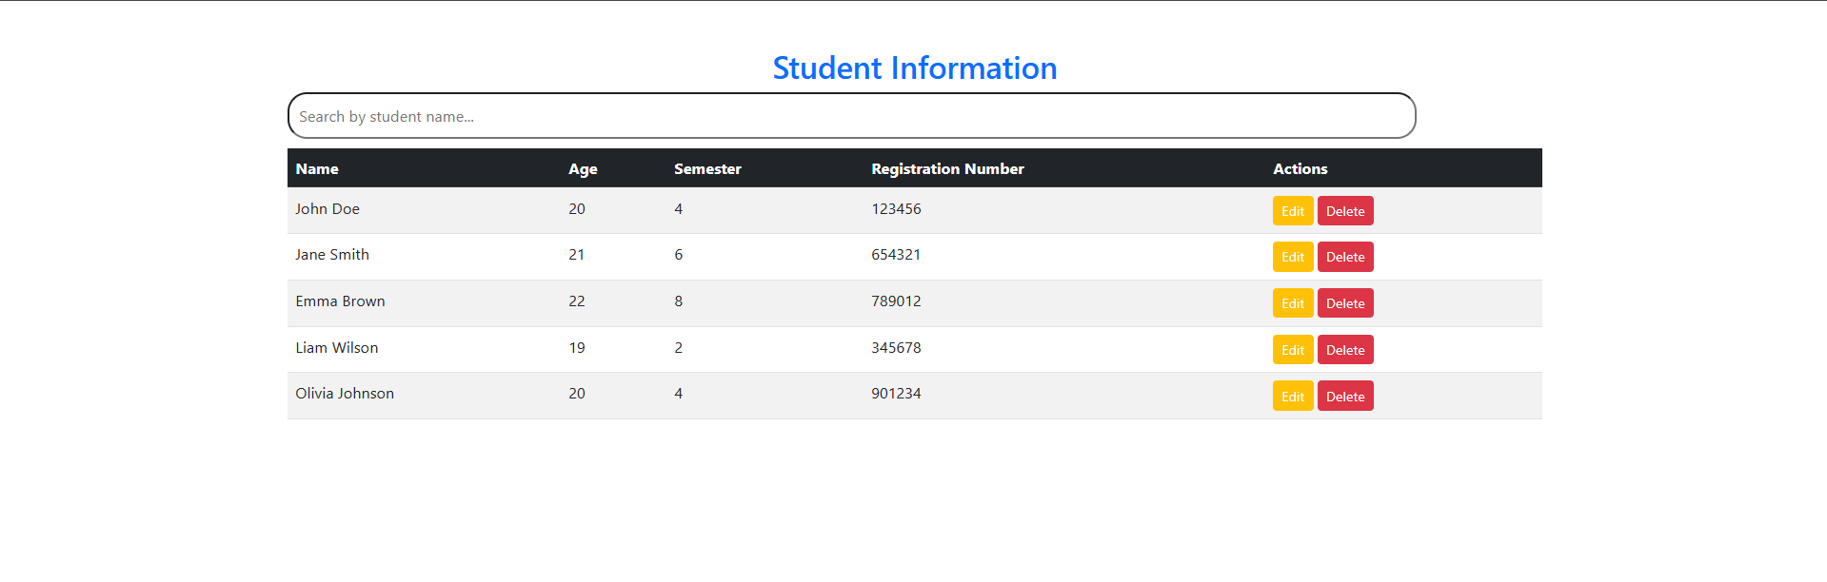

4. After the successful login, the by the user, the page will facilitate navigation buttons Admission, Achievements and Alumni on focus group these buttons and with Bootstrap class and crease drop down option under Achievement. One of the down down items will be Gallery. Use Bootstrap's carousel to display achievement Gallery images.

HTML CODE

<!DOCTYPE html>
<html lang="en">
<head>
<title>Navigation with Bootstrap</title>
<link href="https://cdn.jsdelivr.net/npm/bootstrap@5.3.0/dist/css/bootstrap.min.css" rel="stylesheet">
</head>
<body>
<nav class="navbar navbar-expand-lg navbar-light bg-light">
<a class="navbar-brand" href="#">My Website</a>
<button class="navbar-toggler" data-bs-toggle="collapse" data-bs-target="#navbarNav">
<span class="navbar-toggler-icon"></span>
</button>
<div class="collapse navbar-collapse" id="navbarNav">
<ul class="navbar-nav">
<li><a class="nav-link" href="#">Admission</a></li>
<li class="nav-item dropdown">
<a class="nav-link dropdown-toggle" data-bs-toggle="dropdown">Achievements</a>
<ul class="dropdown-menu">
<li><a class="dropdown-item" href="#gallery">Gallery</a></li>
</ul>
</li>
<li><a class="nav-link" href="#">Alumni</a></li>
</ul>
</div>
</nav>
<div class="container mt-5" id="gallery">
<h2 class="text-center mb-4">Achievements Gallery</h2>
<div id="achievementCarousel" class="carousel slide" data-bs-ride="carousel">
<div class="carousel-inner">
<div class="carousel-item active"><img src="https://via.placeholder.com/600x300" class="d-block w-100" alt="Achievement 1"></div>
<div class="carousel-item"><img src="https://via.placeholder.com/600x300" class="d-block w-100" alt="Achievement 2"></div>
<div class="carousel-item"><img src="https://via.placeholder.com/600x300" class="d-block w-100" alt="Achievement 3"></div>
</div>
<button class="carousel-control-prev" data-bs-target="#achievementCarousel" data-bs-slide="prev">
<span class="carousel-control-prev-icon"></span>
</button>
<button class="carousel-control-next" data-bs-target="#achievementCarousel" data-bs-slide="next">
<span class="carousel-control-next-icon"></span>
</button>
</div>
</div>
<script src="https://cdn.jsdelivr.net/npm/bootstrap@5.3.0/dist/js/bootstrap.bundle.min.js"></script>
</body>
</html>

OUTPUT :-



5. On clicking on Alumni on Focus, create a bootstrap card with images and their short bio and achievements. Add CSS styling to make it more attractive.

HTML CODE

<!DOCTYPE html>
<html lang="en">
<head>
<title>School Management System</title>
<link href="https://cdn.jsdelivr.net/npm/bootstrap@5.3.0/dist/css/bootstrap.min.css" rel="stylesheet">
<script src="https://code.jquery.com/jquery-3.6.0.min.js"></script>
<style>
.card-alumni {
border:1px solid #ddd;
border-radius:10px;
box-shadow:0 4px 8px rgba(0,0,0,.1);
transition:transform .3s;
}
.card-alumni:hover {
transform:scale(1.05);
}
.card-img-top {
border-top-left-radius:10px;
border-top-right-radius:10px;
height:200px;
object-fit:cover;
}
.card-title {
color:#007bff;
font-weight:bold;
}
.modal-header {
background-color:#f8f9fa;
border-bottom:2px solid #007bff;
}
</style>
</head>
<body>
<nav class="navbar navbar-expand-lg navbar-light bg-light">
<div class="container-fluid">
<a class="navbar-brand text-primary" href="#">School Management System</a>
<button class="navbar-toggler" type="button" data-bs-toggle="collapse" data-bs-target="#navbarNav">
<span class="navbar-toggler-icon"></span>
</button>
<div class="collapse navbar-collapse" id="navbarNav">
<ul class="navbar-nav">
<li class="nav-item"><a class="nav-link" href="#">Admission</a></li>
<li class="nav-item dropdown">
<a class="nav-link dropdown-toggle" href="#" id="achievementsDropdown" data-bs-toggle="dropdown">Achievements</a>
<ul class="dropdown-menu" aria-labelledby="achievementsDropdown">
<li><a class="dropdown-item" href="#">Awards</a></li>
<li><a class="dropdown-item" href="#gallery">Gallery</a></li>
</ul>
</li>
<li class="nav-item"><a class="nav-link" href="#" data-bs-toggle="modal" data-bs-target="#alumniModal">Alumni</a></li>
</ul>
</div>
</div>
</nav>
<div class="modal fade" id="alumniModal" tabindex="-1" aria-labelledby="alumniModalLabel" aria-hidden="true">
<div class="modal-dialog modal-lg">
<div class="modal-content">
<div class="modal-header">
<h5 class="modal-title" id="alumniModalLabel">Our Distinguished Alumni</h5>
<button type="button" class="btn-close" data-bs-dismiss="modal"></button>
</div>
<div class="modal-body">
<div class="row g-3">
<div class="col-md-4"><div class="card card-alumni"><img src="https://via.placeholder.com/300x200" class="card-img-top" alt="Alumni 1"><div class="card-body"><h5 class="card-title">Jane Smith</h5><p class="card-text">Software engineer at a top tech firm, multiple innovation awards.</p></div></div></div>
<div class="col-md-4"><div class="card card-alumni"><img src="https://via.placeholder.com/300x200" class="card-img-top" alt="Alumni 2"><div class="card-body"><h5 class="card-title">Michael Johnson</h5><p class="card-text">Renowned scientist, groundbreaking research in renewable energy.</p></div></div></div>
<div class="col-md-4"><div class="card card-alumni"><img src="https://via.placeholder.com/300x200" class="card-img-top" alt="Alumni 3"><div class="card-body"><h5 class="card-title">Emily Davis</h5><p class="card-text">Celebrated author and philanthropist, supporting education worldwide.</p></div></div></div>
</div>
</div>
</div>
</div>
</div>

<script src="https://cdn.jsdelivr.net/npm/bootstrap@5.3.0/dist/js/bootstrap.bundle.min.js"></script>
</body>
</html>

OUTPUT

